

Forest Preparatory School

Personal Social Health Education and Relationships Policy



This policy applies to all pupils in the school, including in the EYFS

**Created**: March 2021

**Reviewed**: August 2024 by Headmaster **Checked:** August 2024 byDeputy Head

**1 |** P a g e

1. Policy Context and Rationale. 3
2. Legislation (Statutory Regulations and Guidelines) 4
3. Roles and Responsibilities 4
4. Curriculum Design 4
5. Safe and Effective Practice 5
6. Equality of Opportunity 6
7. Definition of Relationships and Sex Education (RSE) 6
8. Responsibilities and Delivery Overview 7
9. Managing Difficult Questions 8
10. Parents’ right to withdraw their child. 8
11. Intended Outcomes 9
12. Monitoring and Assessing 9
13. Confidentiality 10
14. Counselling Services 10
15. Outside Speakers 10
16. EYFS 10
17. Dissemination of the Policy 10
18. Further Sources of Information 11

**Appendices**

**Please find the overview of what is taught in each year group, mapped against the DfE statutory guidance and categories:**

Appendix 1 – Relationships and PSHE Programme Overview 11

**Additionally, we have included all lesson objectives for each unit of work to be taught throughout all year groups, from Nursery-Y6:**

Appendix 2- PSHE and Relationships Long Term Plan, from N-Y6, lesson objectives 15

**To give parents and carers a more in-depth look at certain aspects of the curriculum, we have included details of one of the units taught across the school, along with some sample material:**

Appendix 3- Unit of Work- ‘Growing and Changing’ 19

Appendix 4- Example material for ‘Growing and Changing’ 31

**Our pre-existing Healthy Eating Policy**

Appendix 5- Healthy Eating Policy 43

**Scope of this policy**

### Policy Context and Rationale

* 1. This policy covers all pupils and year groups within the school, including the EYFS and sets out the School’s approach to Personal, Social, Health and Economic Education (PSHE) and Relationships delivery.
  2. It was produced through consultation with staff, pupils and parents through (but not limited to) the following channels:
     1. departmental review and feedback
     2. departmental training via the PSHE Association
     3. ongoing parent focus groups
     4. student voice
     5. wellbeing surveys
     6. ongoing feedback from pastoral teams
  3. PSHE education provides a significant contribution to the schools’ responsibility to:
     1. promote children and young people’s wellbeing
     2. achieve the whole curriculum aims
     3. promote community cohesion
     4. provide relationships education
  4. The policy is informed and underpinned by the School’s values of being positive and curious, being respectful and a team player, being engaged and enthusiastic and being well-mannered and kind. In accordance with, and with regard to guidance under Section 80A of the Education Act 2002, the Relationships and PSHE programme aims to develop:
     1. the meaning of and value of life, to appreciate the values of a family life;
     2. have an understanding that love is central to, and the basis of meaningful relationships;
     3. have an understanding of themselves, their physical and emotional development;
     4. reflect on their relationships and recognise the qualities that help relationships to grow and develop positively, behave responsibly within sexual and personal relationships;
     5. develop positive values and a moral framework that will guide their decisions, judgements and behaviour;
     6. have the confidence and self-esteem to value themselves and others;
     7. communicate effectively;
     8. neither exploit or be exploited;
     9. access confidential advice and support;
     10. successful learners who enjoy learning, making progress and achieving;
     11. confident individuals who are able to live safe, healthy and fulfilling lives;
     12. responsible citizens who make a positive contribution to society;
     13. understanding of fundamental British Values and uphold these throughout the curriculum. Our pupils are taught explicitly about British Values which are defined as:
         + democracy & the rule of law
         + individual liberty
         + mutual respect
         + tolerance of those of different faiths and beliefs.

These values are taught explicitly through Personal, Social, Health and Emotional Education (PSHE) as well as through citizenship and the School’s broad and balanced curriculum.

* 1. Parents will be informed about the policy via email communication and the policy will be made available through the school website.

### Legislation (Statutory Regulations and Guidelines)

* 1. Under the Education Act 2002, all schools must provide a balanced broadly-based curriculum which:
     1. Promotes the spiritual, moral, cultural, mental and physical development of pupils at the school and of society;
     2. Prepares pupils at the school for opportunities, responsibilities and experiences of later life.
  2. The 2006 Education and Inspections Act placed a duty on Governing Bodies to promote the wellbeing of pupils at the school.

Revised Department for Education statutory guidance will state that from September 2020 all schools must deliver:

* + 1. Relationships Education (Primary) and Relationships and Sex Education (Secondary)

2.3.2 LGBTQ+ (protected characteristics) inclusion is required as  part of the statutory Relationships Education, [Relationship and Sex Education and Health Education curriculum](https://www.gov.uk/government/publications/relationships-education-relationships-and-sex-education-rse-and-health-education) and there is a range of support available to help schools counter homophobic, biphobic and transphobic bullying and abuse. (KCSIE para 204). Please refer to the Equal Opportunities Policy.

* 1. From 2020, it will be **statutory** for schools to deliver Relationships Education in primary schools, and are **encouraged** by the Department of Education to deliver Sex Education that ensures that both boys and girls are prepared for the changes adolescence brings and – drawing on knowledge of the human life cycle set out in the National Curriculum for science - how a baby is conceived and born. Health Education, which will also be made statutory from 2020, covers the key facts about puberty and the changing adolescent body.

### Roles and Responsibilities

* 1. From September 2020, PSHE and RE delivery across all of the School sites will be monitored by the Head of PSHE and Pastoral Lead. Each school has its own PSHE lead to ensure contextual and appropriate delivery at each key stage. They will be responsible for liaising with other curriculum leads so that curriculum design in different areas complements the RE program, rather than repeating what is already taught. Further detail is outlined in Paragraph 8.
  2. Governance will oversee that the discharge of this policy ensures:
     1. all pupils make progress in achieving the expected educational outcomes;
     2. the subjects are well led, effectively managed and well planned;
     3. the quality of provision is subject to regular and effective self-evaluation;
     4. teaching is delivered in ways which are accessible to all pupils with SEND;
     5. clear information is provided for parents on the subject content and the right to request that their child is withdrawn; and,
     6. the subjects are resourced, staffed and timetabled in a way that ensures that the school can fulfil its legal obligations.

### Curriculum Design

* 1. The curriculum is designed around active engagement in learning, rather than passively receiving information. Pupils will be given opportunities to consider and clarify their values and beliefs and to rehearse and develop enquiry and interpersonal skills.

|  |  |
| --- | --- |
| *School* | Forest Preparatory School |
| *Person(s) Responsible* | Emma Thomson (Head of Pastoral) and Beverley Budd (Director of Studies) |

|  |  |
| --- | --- |
| *Implementation of Curriculum* | -Curriculum time delivered by class teachers and other staff  - Use of SCARF as a source of PSHE and Relationships content and scope  - Weekly, timetabled lessons via a spiral programme  -In upper school, some same-sex classes will be taught. This is to ensure lesson content is delivered in an appropriate and targeted manner, ensuring all children feel secure and confident in seeking any information they may feel they need.  -PSHE is taught through other subjects/curriculum areas e.g. computing  - PSHE delivered through whole school and extended timetable activities  e.g. assemblies   * PSHE enabled through specific projects e.g. awareness days/weeks * Through involvement in the life of the school and wider community * PSHE through pastoral care and guidance.   -All content required to be covered by the national curriculum will have associated material available for children to refer back to; leaflets, books, suggested website etc.   * To ensure that children feel comfortable to learn about a range of topics, we create a safe learning environment using a group agreement at the beginning of lessons or topics. The teachers will also use a range of skills, including distancing techniques and the anonymous question box. Teachers will answer children’s questions factually and honestly in an age-appropriate way and respond to any disclosures following the schools safeguarding procedures/child protection policy which can be found on our website. |
| *Best Practice in PSHE* | * Any new topic in PSHE will be introduced taking into account pupils’ prior knowledge and will complement, not replicate learning in other subjects. Research shows that attempts to scare or shock young people into making healthy choices rarely works and often backfire. * Pupils will be reassured that the majority of young people make positive healthy lifestyle choices. * Pupils are helped to make connections between PSHE education and their ‘real life’ experiences, including online contexts. * Curriculum design around online presence and social media will link to our e-safety and safeguarding policy. |

### Safe and Effective Practice

* 1. PSHE and Relationships learning often draw on pupils’ real-life experiences. A safe and supportive learning environment will be created by establishing ground rules in each context for the delivery of subject material. Staff delivering PSHE and Relationships content will ensure the pupils, who indicate they may be at risk, get appropriate support by liaising with the appropriate pastoral team and adhering to the School’s Child Protection and Safeguarding Policy.

5.2 Within the curriculum design there are opportunities to teach safeguarding within the RSE and Health curriculum in accordance with KCSIE 2024, which states: *Preventative education is most effective in the context of a whole-school or college approach that prepares pupils and students for life in modern Britain and creates a culture of zero tolerance for sexism, misogyny/misandry, homophobia, biphobic and sexual violence/harassment... These will be underpinned by the school/college’s behaviour policy, the Equal Opportunities policy and pastoral support system, as well as by a planned programme of evidence-based RSHE delivered in regularly timetabled lessons and reinforced throughout the whole curriculum. Such a programme should be fully inclusive and developed to be age and stage of development appropriate (especially when considering the needs of children with SEND and other vulnerabilities). NB:* **If any safeguarding issues are raised during RSHE lessons, the school will  refer to its Safeguarding policy.**

### Equality of Opportunity

* 1. Classroom practice and pedagogy will take into account pupils’ development, age, ability, readiness and cultural background, protected characteristics and pupils with SEND and will be adjusted accordingly to enable all students to access the learning. We will use PSHE and Relationships programme to address diversity issues and to ensure equality for all by addressing contextual issues identified through our pastoral management system and wellbeing surveys.

PSHE and Relationships delivery is designed to comply with the Equality Act 2010. Provisions within the Equality Act allow the School to take positive action, where it can be shown that it is proportionate, to deal with particular disadvantages affecting one group because of protected characteristics, such as age, gender, disability, race, religion, beliefs, sexual orientation

* 1. Relationships education takes account of the faith of individual pupils as well as the nature of the faith of the school, whilst helping pupils from all backgrounds build positive and safe relationships and to thrive in modern Britain. When planning for teaching the religious background of pupils will be observed so that topics are appropriately handled.

6.3 Parents have the right to withdraw their children from those parts of the Relationships programme not within the national curriculum. Further details of this can be found in Section 10.

### Definition of Relationships and Sex Education (RSE)

* 1. Relationships and Sex Education (RSE) is learning about the emotional, social and physical aspects of growing up, relationships, diverse families, sex, human sexuality and sexual health. It should equip children and young people with the information, skills and positive values to have safe, fulfilling relationships, to enjoy their sexuality and to take responsibility for their sexual health and well-being.
  2. RSE is an entitlement for all children and young people and must:
     1. Be accurate and factual, covering a comprehensive range of information about sex, relationships, the law and sexual health, in order to make informed choices. In schools this should be part of compulsory curriculum provision;
     2. Be inclusive in terms of gender, sexual orientation, disability, ethnicity, culture, age, religion or belief or and protected characteristics or other life-experience particularly HIV status and pregnancy;
     3. Include the development of skills to support healthy and safe relationships and ensure good communication about these issues;
     4. Promote a critical awareness of the different attitudes and views on sex and relationships within society such as peer norms and those portrayed in the media;
     5. Seeks to break down stereotypes, tackle negative behaviours and build a culture of positive tolerance and understanding consistently role modelled by all staff at the school.
     6. Provide opportunities for reflection in order to nurture personal values based on mutual respect and care;
     7. Be part of lifelong learning, starting early in childhood and continuing throughout life. It should reflect the age and level of the learner;
     8. Ensure children and young people are clearly informed of their rights such as how they can access confidential advice and health services within the boundaries of safeguarding;
     9. Be relevant and meet the needs of children and young people, and actively involve them as participants, advocates and evaluators in developing good quality provision;
     10. Be delivered by competent and confident educators;
     11. Be provided within a learning environment which is safe for the children, young people and adults involved and based on the principle that prejudice, discrimination and bullying are harmful and unacceptable.

### Responsibilities and Delivery Overview

|  |  |
| --- | --- |
| *Job role* | *Person(s) responsible* |
| Pastoral Lead | Emma Thomson |
| PSHE Lead | Emma Thomson |
| Relationships Co-ordinator | Emma Thomson |
| Science co-ordinator | Louise Knowles |
| The focus during PSHE and Relationship learning in Forest focuses on:   * the fundamental building blocks and characteristics of positive relationships, with particular emphasis on friendships, family and relationships with other children and adults; * differences in families and their structure and respect for the individual circumstances of families.   It addresses the relationships between:   * physical health and mental well being * the balance of online and other activities * emotion and the ability to express emotions   Unlike Relationships education, sex education is not compulsory for pupils receiving primary education, although some primary schools may choose to teach it. Following teacher and SLT consultation, the School has decided that, apart from the sex education content included in the science curriculum for the primary age range, conception and non-statutory sex education will not be provided at Forest School.  This is not to say that certain elements of the non-statutory curriculum will not be covered more informally by teachers based on:   * 1. The apparent needs of the individual cohorts   2. Parental consultation with teachers.   If a class teacher were to cover anything non-statutory, parents would be consulted, informed and  have the right to withdraw their child from that lesson (refer to section 10 for more information about withdrawal). | |

### Managing difficult questions:

* 1. Having an open forum which encourages confidence and security is vital in PSHE and Relationship lessons. The school believes that pupils should have their questions answered in a sensible and matter of fact manner. However, there may be times when a question is asked which may be inappropriate to answer publicly, these questions may be addressed outside the lesson time. Teachers will use their skill and discretion in these situations and refer to the Headmaster if necessary.

### Parents’ right to withdraw their child

* 1. Parents have the right request to withdraw their children from non-statutory ‘sex education’ lessons. They do not have a right to withdraw their children from those aspects of sex education which are taught in the statutory National Curriculum Science and Health Education. Parents are invited to view our resources and discuss any concerns with our staff.
  2. Before granting a request to withdraw a child/ren, the Headmaster will invite the parent to discuss the request with them to ensure that their wishes are understood and to clarify the nature and purpose of the curriculum. The Headmaster will discuss with the parent the benefits of receiving this important education and any detrimental effects that withdrawal might have on their child. This could include any social and emotional effects of being excluded, as well as the likelihood of the child hearing their peers’ version of what was said in the classes, rather than what was directly said by the teacher (although the detrimental effects may be mitigated if the parent proposes to deliver sex education to their child at home instead). The school is responsible for ensuring that should a child be withdrawn, they receive appropriate, purposeful education during the period of withdrawal.
  3. Parents should be given every opportunity to understand the purpose and content of Relationships Education and Sex Education. Good communication and opportunities for parents to understand and ask questions about our school’s approach help increase confidence in the curriculum.
  4. It is statutory for our school to show parents examples of the resources we plan to use. We will provide opportunities for parents to view examples through class/year group meetings either face to face or virtually. We advise parents to view the resources in order to support them in carrying out their responsibilities relating to providing RSE at home. It is valuable for a child’s development to learn about its own family’s values in regard to relationships and sex alongside the information they receive at school.
  5. We will continually work in active partnership with parents, value their views and keep them informed about PSHE and Relationships provision. If a parent has any concerns about the provision, we will take time to address these concerns and allay any fears they may have.

### Intended Outcomes

* 1. As a result of our PSHE and Relationships programme, pupils will:
     1. Develop the knowledge, skills and personal attributes they need to manage their lives now and in the future
     2. Learn to make responsible decisions e.g. about alcohol, drugs, relationships and future careers
     3. Learn to recognise and manage risk and take increasing responsibility for themselves and their actions both online and in their daily lives
     4. Understand the importance of wellbeing and how to tackle issues that can affect their ability to learn and their mental health
     5. Understand the characteristics of and the importance of building healthy and positive relationships both online and in their daily lives
     6. Develop skills such as teamwork, communication and resilience
     7. Be encouraged to make positive contributions to their families, schools and communities
     8. Explore differences and learn to value diversity in all its forms
     9. Reflect on their own individual values and attitudes
     10. Identify and articulate feelings and emotions and manage difficult situations positively
     11. Understand the importance to our bodies and health of eating healthily. This concept will be

reinforced with our ‘Healthy Eating Policy’ (appendix 5).

### Monitoring and Assessing

* 1. The effectiveness of the PSHE and Relationships provision will be evaluated through annual governance (spring) and half termly summative assessments, carried out by class teachers.
     1. We use three methods of monitoring and assessing learning within the PSHE and Relationships programme at Forest Preparatory School:
     2. *SCARF Progress*

For each of the six units we carry out a specially designed pre- and post-unit assessment activity. Conducted twice, first at the beginning of the unit to determine where the children are at; and then again at the end of the unit, enabling us to monitor progress, record key points and identify areas for further development. This enables both teacher and child to see what progress has been made over the course of each half- termly unit of lesson plans.

* + 1. *SCARF Success*

At the end of a unit, we consider a range of ‘I can' statements, which summarise children’s learning against the unit's key learning outcomes.

* + 1. *Wearing my SCARF*

This approach encourages children to reflect personally on their learning. They can record what they found helpful, thought-provoking, challenging and where their learning might take them to next. This also plays a key role in helping us to evaluate the programme.

* + 1. This method of recording also enables the teacher to make an annual assessment of progress for each child, as part of the child’s annual report to parents. We pass this information on to the next teacher at the end of each year.
    2. The monitoring of the standards of children’s work and of the quality of PSHE and RE education is the responsibility of the PSHE/Relationships subject lead. The work of the subject lead also involves supporting colleagues in the teaching of PSHE and Relationships education and being informed about current developments in the subject.
    3. The PSHE/Relationships subject lead gives the head teacher an annual summary report, in which teaching and learning of the subject is evaluated. Areas for development are also identified. If required, the PSHE/Relationships subject lead has specially allocated regular management time, enabling them to review evidence of the children’s work and monitor any assessments made.
    4. Application of knowledge and skills in wider school participation, resolving conflict, making decisions and forming positive relationships. Pupil voice will be influential in adapting and amending the material for the PSHE and Relationships programme to ensure it is up to date and relevant.

### Confidentiality

* 1. PSHE and Relationship lessons will be conducted in a sensitive manner within a secure and safe environment. Sometimes, pupils may wish to make a disclosure to a member of staff. Pupils will be made aware that some information cannot be held confidentially and will be informed that, if certain disclosures are made, the information may be disclosed to the Safeguarding team.

See Safeguarding Children Policy, Anti Bullying Policy, Parent/Staff Communication Policy.

### Counselling Services

* 1. Pupils are made aware of counselling and information services both in and out of school and offered appropriate support.

### Outside Speakers

* 1. Please refer to Section 16 of the Safeguarding policy for details of procedures for Vetting Visiting Speakers.

### EYFS

* 1. In the Early Years Foundation Stage, the Relationships Education, Relationships and Sex Education and Health Education (England) Regulations 2019 and the accompanying statutory guidance do not apply; however Personal Social and Emotional Development (PSED) is one of the prime areas within the EYFS curriculum and age-appropriate provision is made accordingly.

### Dissemination of the Policy

* 1. This policy has been made accessible to parents, teachers, other school staff and governors through the school website. Anyone wanting a printed copy or the policy to be provided in another language or format, should make a request to the school office. Should the policy be required in other languages, please contact the school office.

Should further information about PSHE and Relationships be required, please contact the PSHE/Relationships lead, Mr Rick Hyde (Deputy Head- Pastoral)

### Sources of Further Information

* 1. This policy should be read in conjunction with the following:
     1. School’s own Safeguarding/Child Protection policy (inc. responding to disclosures)
     2. School’s own Confidentiality policy
     3. School’s own Anti-bullying policy
     4. School’s own Equality, diversity and inclusion policy
     5. DfE ‘Keeping children safe in education’ (2019).

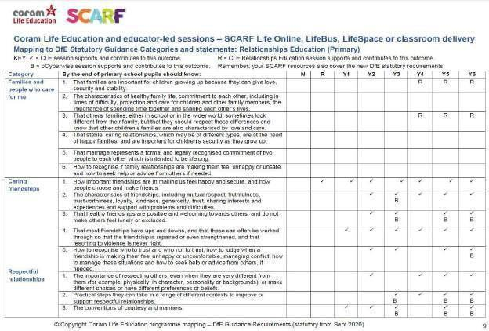

Appendix 1- Overview of Curriculum mapped against the DfE statutory guidance and categories:

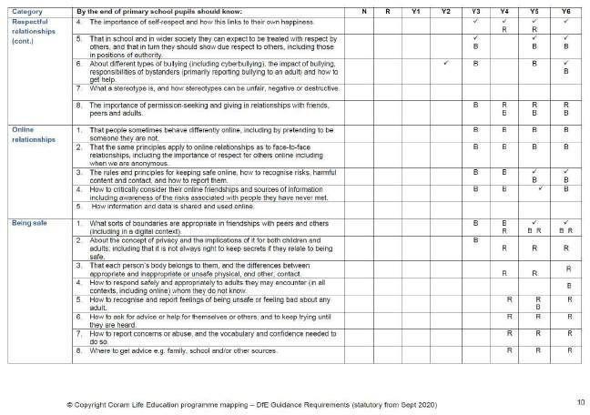

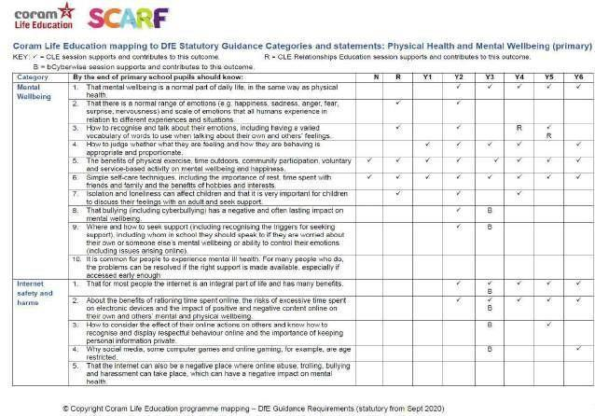

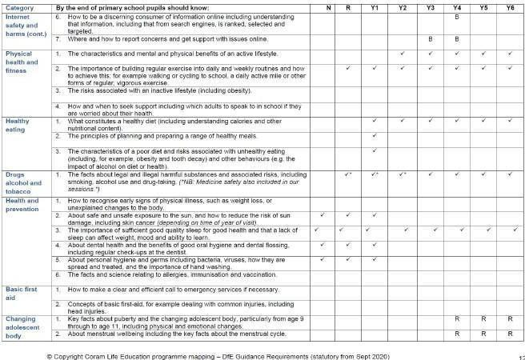

Appendix 2- Relationships and PSHE Long Term Plan

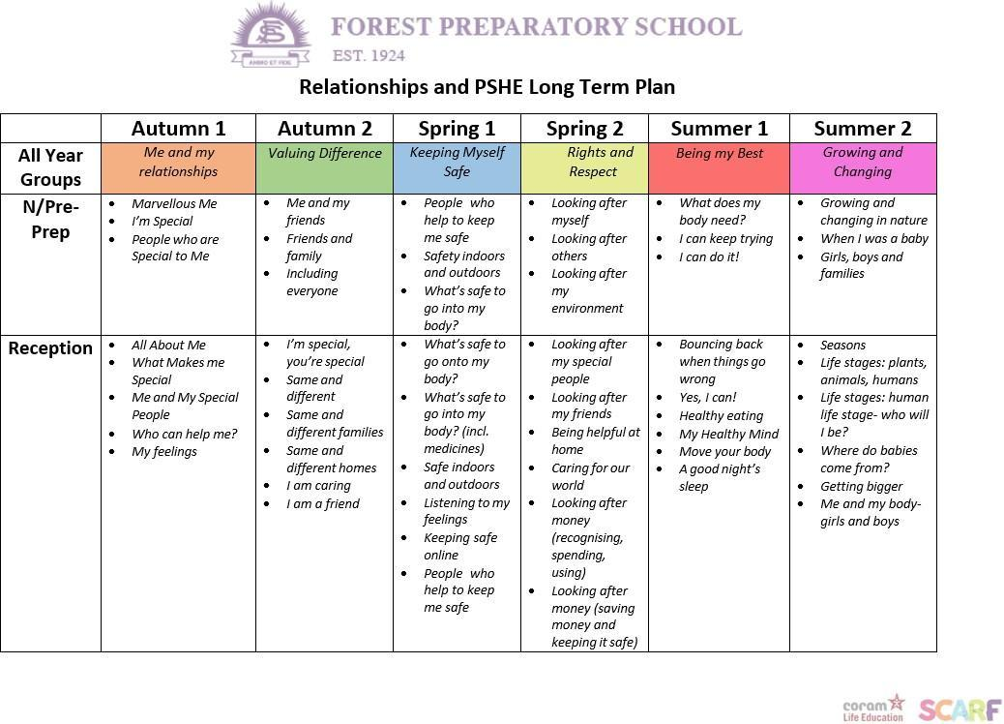

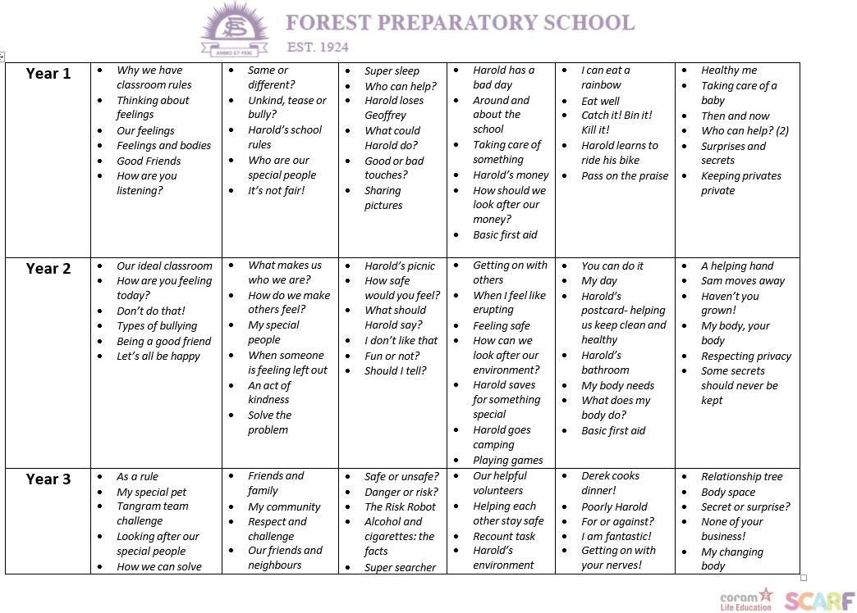

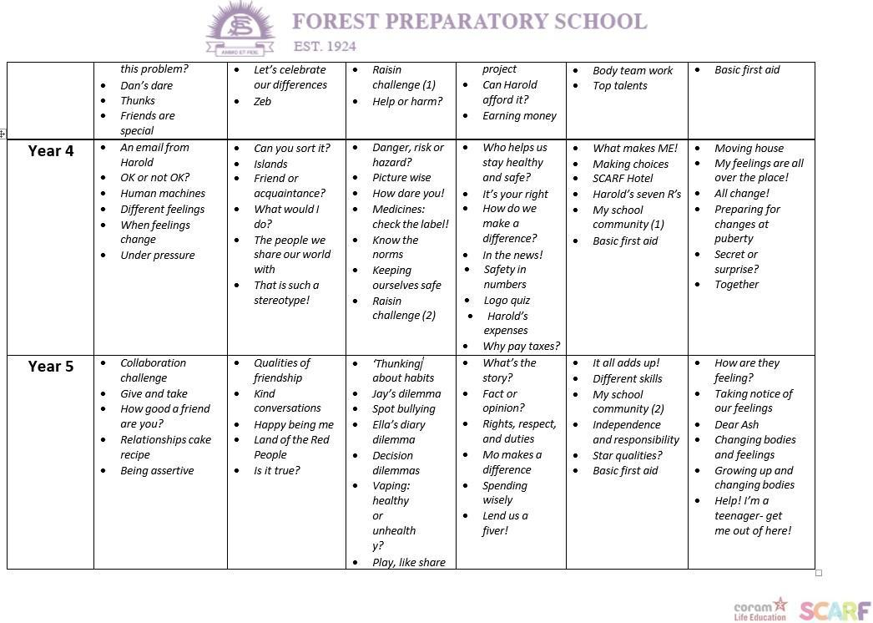

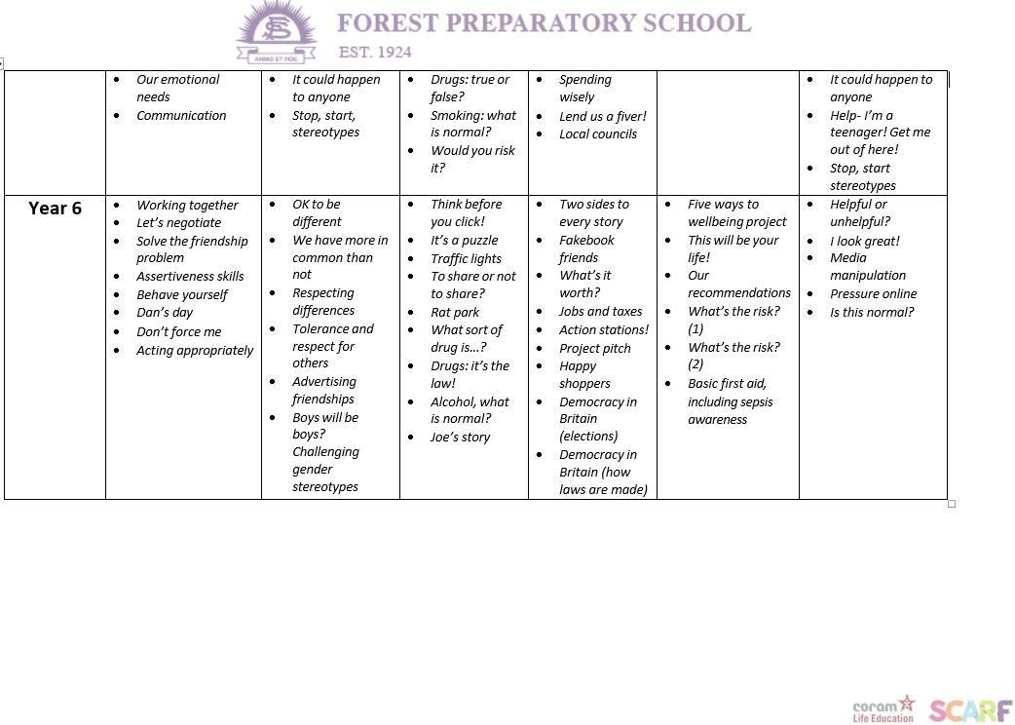

Appendix 3- Unit of Work- ‘Growing and Changing’

# Unit of Work for Relationships Education

***‘Growing and Changing’* Overview**

|  |  |  |  |
| --- | --- | --- | --- |
| **Year group** | **Lesson Topic** | **Lesson Objective(s)** | **Notes** |
| *Nursery*  */ Pre- Prep* | Growing and changing in nature | * To understand what ‘change’ means. * To observe some changes in our everyday environment. |  |
| When I was a baby | * Understand that babies change and grow. * Understand what babies require to grow. |  |
| Girls, boys and families | * To understand there should be no constraints for children, purely based on whether they are **boys** or **girls**. | * *Sample material available* |
|  | | |

|  |  |  |  |
| --- | --- | --- | --- |
| **Year group** | **Lesson Topic** | **Lesson Objective(s)** | **Notes** |
| *Receptio n* | Seasons | * Name the different seasons and describe their differences. * Explain the changes that occur as seasons change. * Talk about how they have grown in resilience. |  |
| Life stages- plants, animals, humans | * To understand that animals and humans change in appearance over time. * Use relevant vocabulary such as egg, seed, baby, grow, change, old, young (and the names for young animals). * Make observations and ask questions about living things. |  |
| Life stages: Human life stages, who will I be? | * Retell a story and respond to questions about it. * Use the language and describe the different life stages of: baby, child, teenager, adult, older age. * Talk about their own experience of growing up. |  |
| Where do babies come from? | * Explain that a baby is made by a woman and a man, and grows inside a mother’s tummy. * Understand that every family is different. * Talk about similarities and differences between themselves and others. | * *Sample material available* |
| Getting bigger | * Talk about how they have changed as they have grown. * Explain the differences between babies, children, and adults. * Understand that we are all unique. |  |
| Me and my body- girls and boys | * Name parts of the body (including reproductive parts) using the correct vocabulary. * Explain which parts of their body are kept private and safe and why. | * *Sample material available* |

|  |  |  |  |
| --- | --- | --- | --- |
|  |  | * Tell or ask an appropriate adult for help if they feel unsafe. |  |
|  | | |

|  |  |  |  |
| --- | --- | --- | --- |
| **Year group** | **Lesson Topic** | **Lesson**  **Objective(s)** | **Notes** |
| *Year 1* | Inside my wonderful body! | * Name major internal body parts (heart, lungs, blood, stomach, intestines, brain). * Understand and explain the simple bodily processes associated with them. |  |
| Taking care of a baby | * Understand some of the tasks required to look after a baby. * Explain how to meet the basic needs of a baby, for example, eye contact, cuddling, washing, changing, feeding. |  |
| Then and now | * Identify things they could do as a baby, a toddler and can do now. * Identify the people who help/helped them at those different stages. |  |
| Who can help | * Explain the difference between teasing and bullying. * Give examples of what they can do if they experience or witness bullying. * Say who they could get help from in a bullying situation. |  |
| Surprises and secrets | * Explain the difference between a secret and a nice surprise. * Identify situations as being secrets or surprises. * Identify who they can talk to if they feel uncomfortable about any secret they are told, or told to keep. |  |
| Keeping privates private | * Identify parts of the body that are private. * Describe ways in which private parts can be kept private. * Identify people they can talk to about their private parts. | * *Sample material available.* |
| *Additional notes: If any variation of the body parts ‘penis’ or ‘vagina’ are mentioned by the children, the teacher will refer to these as our ‘private parts’.* | | |

|  |  |  |  |
| --- | --- | --- | --- |
| **Year group** | **Lesson Topic** | **Lesson**  **Objective(s)** | **Notes** |
| *Year 2* | A helping hand! | * To demonstrate simple ways of giving positive feedback to others. |  |
| Sam moves away | * Recognise the range of feelings that are associated with losing (and being reunited) with a person they are close to. |  |
| Haven’t you grown! | * Identify different stages of growth (e.g. baby, toddler, child, teenager, adult); * Understand and describe some of the things that people are capable of at these different stages. |  |
| My body, your body | * Identify which parts of the human body are private. Referred to as ‘boys’ private parts’ and ‘girls’ private parts’. * Understand that humans mostly have the same body parts but that they can look different from person to person. | * *Sample material available* |
| Respecting privacy | * Explain what privacy means. * Know that you are not allowed to touch someone’s private belongings without their permission. * Give examples of different types of private information. |  |
| *Additional notes: If any variation of the body parts ‘penis’ or ‘vagina’ are mentioned by the children, the teacher will refer to these as our ‘private parts’.* | | |

|  |  |  |  |
| --- | --- | --- | --- |
| **Year group** | **Lesson Topic** | **Lesson Objective(s)** | **Notes** |
| *Year 3* | Relationship Tree | * Identify different types of relationships. * Recognise who they have positive healthy relationships with. |  |
| Body space | * Understand what is meant by the term body space (or personal space). * Identify when it is appropriate or inappropriate to allow someone into their body space. * Rehearse strategies for when someone is inappropriately in their body space. |  |
| Secret or surprise? | * Define the terms 'secret' and 'surprise' and know the difference between a safe and an unsafe secret. * Recognise how different surprises and secrets might make them feel. * Know who they could ask for help if a secret made them feel uncomfortable or unsafe. |  |
|  | | |

|  |  |  |  |
| --- | --- | --- | --- |
| **Year group** | **Lesson Topic** | **Lesson Objective(s)** | **Notes** |
| *Year 4* | Moving house | * Describe some of the changes that happen to people during their lives. * Explain how the Learning Line can be used as a tool to help them manage change more easily. * Suggest people who may be able to help them deal with change. |  |
| My feelings are all over the place | * Name some positive and negative feelings. * Understand how the onset of puberty can have emotional as well as physical impact. * Suggest reasons why young people sometimes fall out with their parents. * Take part in a role play practising how to compromise. |  |
| All change | * Identify parts of the body that males and females have in common and those that are different. * Know the correct terminology for their genitalia. * * Understand and explain why puberty happens. | * *Sample material available* |
| Preparing for periods | * Know the key facts of the menstrual cycle. * Understand that periods are a normal part of puberty for girls. * Identify some of the ways to cope better with periods. | * *Sample material available* |
| Secret or surprise? | * Define the terms 'secret' and 'surprise' and know the difference between a safe and an unsafe secret. * Recognise how different surprises and secrets might make them feel. * Know who they could ask for help if a secret made them feel uncomfortable or unsafe. |  |
| Together | * Understand that marriage is a commitment to be entered into freely and not against someone's will. * Recognise that marriage includes same sex and opposite sex partners. |  |

|  |  |  |  |
| --- | --- | --- | --- |
|  |  | * Know the legal age for marriage in England or Scotland. * Discuss the reasons why a person would want to be married, or live together, or have a civil ceremony. |  |
| *Additional notes: the term ‘private parts’ as previously used in KS1 will now be given biologically accurate names.*  *\**(**Female**: vulva, vagina, ovaries, eggs, womb, clitoris, labia, breasts; **Male**: penis, testicles, sperm, pubic hair). | | |

|  |  |  |  |
| --- | --- | --- | --- |
| **Year group** | **Lesson Topic** | **Lesson Objective(s)** | **Notes** |
| *Year 5* | How are they feeling? | * Use a range of words and phrases to describe the intensity of different feelings. * Distinguish between good and not so good feelings, using appropriate vocabulary to describe these. * Explain strategies they can use to build resilience. |  |
| Taking notice of our feelings | * Identify people who can be trusted. * Understand what kinds of touch are acceptable or unacceptable. * Describe strategies for dealing with situations in which they would feel uncomfortable, particularly in relation to inappropriate touch. |  |
| Dear Hetty | * Explain how someone might feel when they are separated from someone or something they like. * Suggest ways to help someone who is separated from someone or something they like. |  |
| Changing bodies and feelings | * Know the correct words for the external sexual organs. * * Discuss some of the myths associated with puberty. | * *Delivered in single sex groups.* * *Sample material available*. |
| Growing up and changing bodies | * Identify some products that they may need during puberty and why. * Know what menstruation is and why it happens. | * *Sample material available*. |
| Help! I’m a teenager, get me out of here! | * Recognise how our body feels when we’re relaxed. * List some of the ways our body feels when it is nervous or sad. * Describe and/or demonstrate how to be resilient in order to find someone who will listen to you. |  |

|  |  |  |  |
| --- | --- | --- | --- |
|  | It could happen to anyone | * Identify the consequences of positive and negative behaviour on themselves and others. * Give examples of how individual/group actions can impact on others in a positive or negative way. |  |
| Stop, start, stereotypes | * Recognise that some people can get bullied because of the way they express their gender. * Give examples of how bullying behaviours can be stopped. |  |
| *Additional notes: the term ‘private parts’ as previously used in KS1 will now be given biologically accurate names.*  *\*(***Female***: vulva, outer lips, inner lips, clitoris, anus.* **Male***: foreskin, anus, penis, scrotum, testicles).* | | |

|  |  |  |  |
| --- | --- | --- | --- |
| **Year group** | **Lesson Topic** | **Lesson Objective(s)** | **Notes** |
| *Year 6* | Helpful or unhelpful? Managing change | * Recognise some of the changes they have experienced and their emotional responses to those changes. * Suggest positive strategies for dealing with change. * Identify people who can support someone who is dealing with a challenging time of change. |  |
| I look great! | * Understand that fame can be short-lived. * Recognise that photos can be changed to match society's view of perfect. * Identify qualities that people have, as well as their looks. |  |
| Media manipulation | * Define what is meant by the term stereotype. * Recognise how the media can sometimes reinforce gender stereotypes. * Recognise that people fall into a wide range of what is seen as normal. * Challenge stereotypical gender portrayals of people |  |
| Pressure online | * Understand the risks of sharing images online and how these are hard to control, once shared. * Understand that people can feel pressured to behave in a certain way because of the influence of the peer group. * Understand the norms of risk-taking behaviour and that these are usually lower than people believe them to be. | * *Delivered in single sex groups.* * *Sample material available*. |
| Is this normal? | * Define the word 'puberty' giving examples of some of the physical and emotional changes associated with it. * Suggest strategies that would help someone who felt challenged by the changes in puberty. * Understand what FGM is and that it is an illegal practice in this country. * Know where someone could get support if they were   concerned about their own or another person's safety. | * *Sample material available.* |
| Dear Ash | * Explain the difference between a safe and an unsafe |  |

|  |  |  |  |
| --- | --- | --- | --- |
|  |  | secret.   * Identify situations where someone might need to break a confidence in order to keep someone safe. |  |
| *Additional notes: the term ‘private parts’ as previously used in KS1 will now be given biologically accurate names.*  *\*(***Female***: vulva, outer lips, inner lips, clitoris, anus.* **Male***: foreskin, anus, penis, scrotum, testicles).* | | |

Appendix 4- Sample Material for ‘Growing and Changing’

|  |  |  |
| --- | --- | --- |
| ***Year*** | ***Topic*** | ***Learning objectives*** |
| Nursery | Girls, boys and families | * To understand there should be no constraints for children, purely based on whether they are **boys** or **girls**. |

***Useful links associated with the topic:*** [https://www.scholastic.com/teachers/articles/teaching-content/ages-stages-im-boy-youre-](https://www.scholastic.com/teachers/articles/teaching-content/ages-stages-im-boy-youre-girl/) [girl/](https://www.scholastic.com/teachers/articles/teaching-content/ages-stages-im-boy-youre-girl/)

<https://www.youtube.com/watch?v=QgRFVSC9BmU>

[https://www.britishcouncil.org/voices-magazine/how-approach-teaching-gender-equality-boys-and-](https://www.britishcouncil.org/voices-magazine/how-approach-teaching-gender-equality-boys-and-girls) [girls](https://www.britishcouncil.org/voices-magazine/how-approach-teaching-gender-equality-boys-and-girls)

|  |  |  |
| --- | --- | --- |
| ***Year*** | ***Topic*** | ***Learning objectives*** |
| Reception | Where do babies come from? | * Explain that a baby is made by a woman and a man, and grows inside a mother’s tummy. * Understand that every family is different. * Talk about similarities and differences between themselves and others. |

#### Book to read to children:

*There’s a House Inside my Mummy* by Giles Andrae and Vanessa Cabban.

<https://www.youtube.com/watch?v=egIS60CfWQQ>

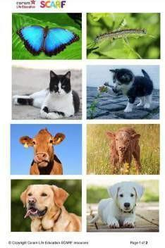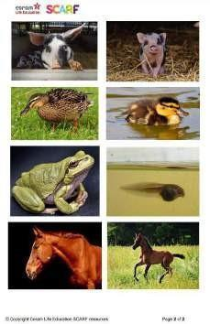

|  |  |  |
| --- | --- | --- |
| ***Year*** | ***Topic*** | ***Learning objectives*** |
| Reception | Me and my body- girls and boys | * Name parts of the body using the correct vocabulary. * Explain which parts of their body are kept private and safe and why. * Tell or ask an appropriate adult for help if they feel unsafe. |

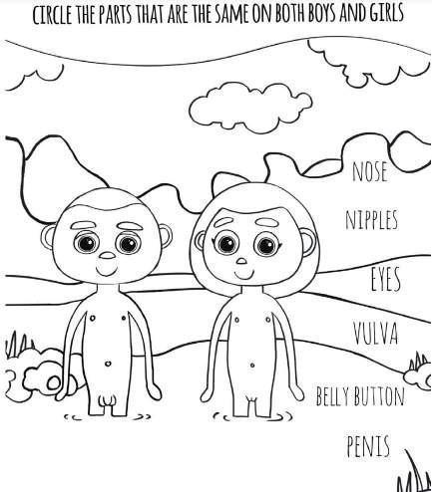

***Useful links associated with the topic:***

<https://www.youtube.com/watch?v=-lL07JOGU5o>

|  |  |  |
| --- | --- | --- |
| ***Year*** | ***Topic*** | ***Learning objectives*** |
| Year 1 | Keeping privates private | * Identify parts of the body that are private. * Describe ways in which private parts can be kept private. * Identify people they can talk to about their private parts. |

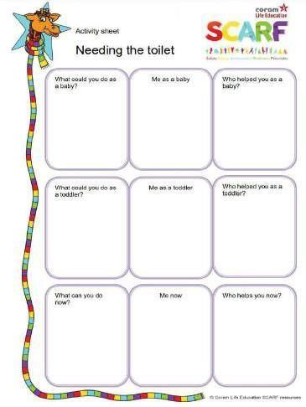

|  |  |  |
| --- | --- | --- |
| ***Year*** | ***Topic*** | ***Learning objectives*** |
| Year 2 | My body, your body | * Identify which parts of the human body are private. Referred to as ‘boys’ private parts’ and ‘girls’ private parts’. * Understand that humans mostly have the same body parts but that they can look different from person to person. |

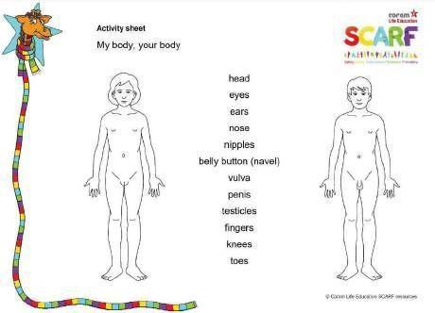

|  |  |  |
| --- | --- | --- |
| ***Year*** | ***Topic*** | ***Learning objectives*** |
| Year 4 | All change | * Identify parts of the body that males and females have in common and those that are different. * Know the correct terminology for their genitalia. * Understand and explain why puberty happens. |

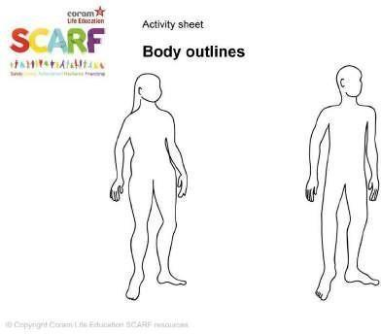

To be labelled with:

* **Female:** vulva, (see note, below*), vagina, ovaries, eggs, womb, clitoris, labia, breasts
* **Male:** penis, testicles, sperm, pubic hair

|  |  |  |
| --- | --- | --- |
| ***Year*** | ***Topic*** | ***Learning objectives*** |
| Year 3/4 | My Changing Body | * Recognise that babies come from the joining of an egg and sperm. * Explain what happens when an egg doesn’t meet a sperm. * Understand that for girls, periods are a normal part of puberty. |

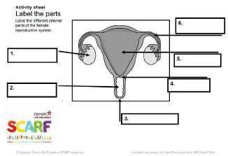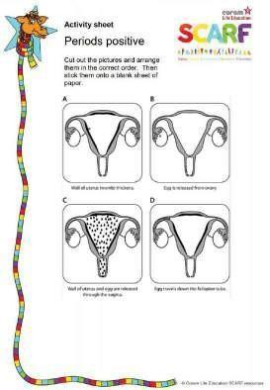

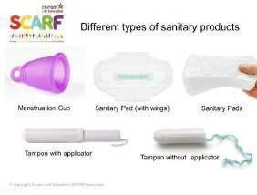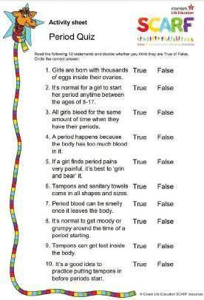

|  |  |  |
| --- | --- | --- |
| ***Year*** | ***Topic*** | ***Learning objectives*** |
| Year 4 | Preparing for periods | * Know the key facts of the menstrual cycle. * Understand that periods are a normal part of puberty for girls. * Identify some of the ways to cope better with periods. |

#### Video on menstruation using the following link:

<https://kidshealth.org/en/teens/menstruation.html>

|  |  |  |
| --- | --- | --- |
| ***Year*** | ***Topic*** | ***Learning objectives*** |
| Year 5 | Changing bodies and feelings | * Know the correct words for the external sexual organs. * Discuss some of the myths associated with puberty. |

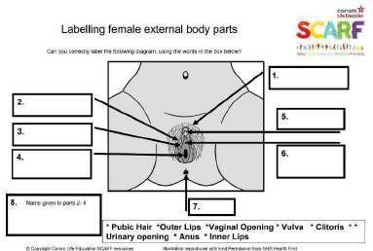

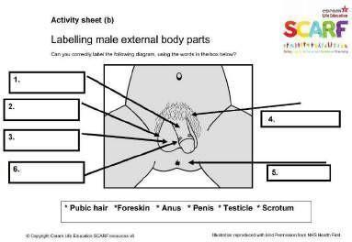

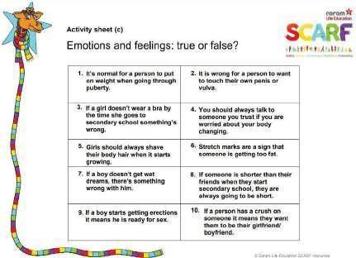

|  |  |  |
| --- | --- | --- |
| ***Year*** | ***Topic*** | ***Learning objectives*** |
| Year 5 | Growing up and changing bodies | * Identify some products that they may need during puberty and why. * Know what menstruation is and why it happens. |

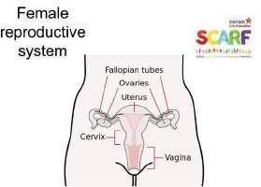

## A bag including items which may be regarded as useful when going through puberty: deodorant, menstruation options, spot/facial creams, shower gel, tissues etc.

|  |  |  |
| --- | --- | --- |
| ***Year*** | ***Topic*** | ***Learning objectives*** |
| Year 6 | Pressure online | * Understand the risks of sharing images online and how these are hard to control, once shared. * Understand that people can feel pressured to behave in a certain way because of the influence of the peer group. * Understand the norms of risk-taking behaviour and that these are usually lower than people believe them to be. |

#### Video on the risks of sharing images online using the following link:

[*https://www.youtube.com/watch?v=kwcL-VP3FYc*](https://www.youtube.com/watch?v=kwcL-VP3FYc)

|  |  |  |
| --- | --- | --- |
| ***Year*** | ***Topic*** | ***Learning objectives*** |
| Year 6 | Is this normal? | * Define the word 'puberty' giving examples of some of the physical and emotional changes associated with it. * Suggest strategies that would help someone who felt challenged by the changes in puberty. * Understand what FGM is and that it is an illegal practice in this country. * Know where someone could get support if they were concerned about their own or another person's safety. |

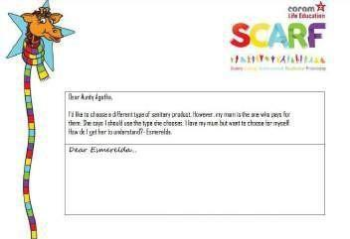

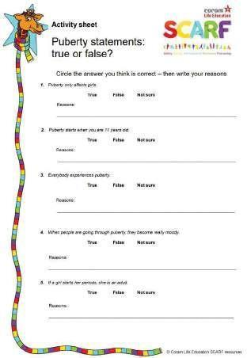 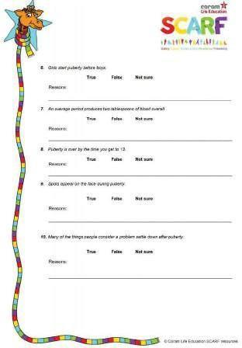

Appendix 5- Healthy Eating Policy



# HEALTHY EATING POLICY

Forest Preparatory School is committed to following a healthy eating policy which will ultimately benefit all children and staff. This follows our Healthy Schools Award as presented by Trafford Council.

* Food served at the school shall generally be considered to be food of a healthy nature. Chips and fatty foods are not regularly on the menu but a healthy alternative is always available if they are to be served.
* All children are expected to eat school lunches and they will not be allowed to bring their own in, except under exceptional circumstances.
* Alternative options will be made available for children who have dietary requirements due to religious or medical reasons.
* All packed lunches for expeditions will be of a healthy nature and include fruit.
* A salad option will be available to children and staff.
* Surveys are occasionally conducted with pupils and the School Council are involved in discussions regarding healthy meal options.
* During PSHE and science lessons, children in all classes are educated to eat healthy foods and there are often displays around school to promote healthy eating.
* No child should bring sweets or foods with high fat content into school and all break time snacks should be of a healthy nature e.g. fruit bars, fruit etc.
* Children are issued with a water bottle on entry to Reception and water is always accessible to all children, including Early Years, during and between lessons.
* There is a fruit stall open to all children most Wednesday’s at morning playtime.